

Happy 4th Birthday

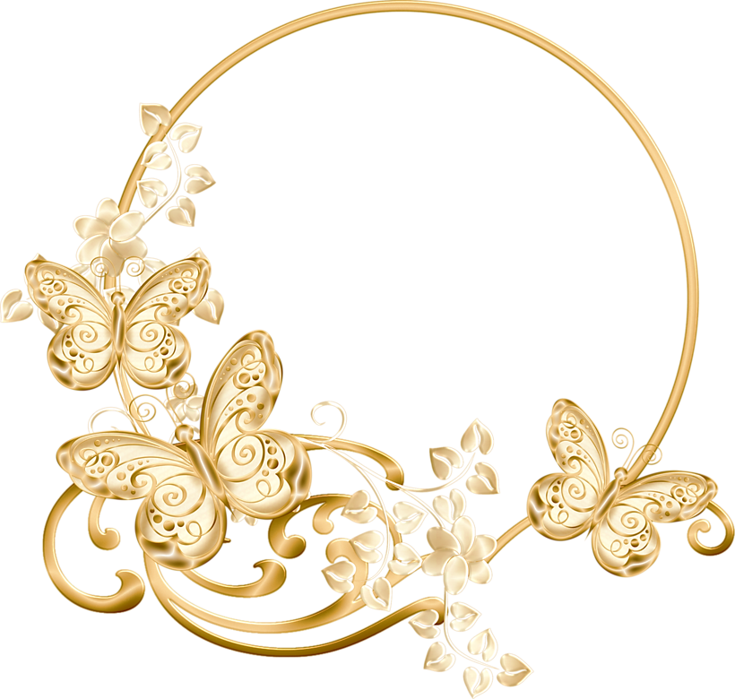

**Issa**

Happy 8th Birthday

From: Papa & Mama

From: Papa & Mama

**Sophia**

Happy 63rd Birthday

Mama Nora